CHAPTER 5 - HUMAN RESPONSE TO THE ENVIRONMENT
THE NERVOUS SYSTEM
QUESTION 1
1. C
2. A
3. A
4. B
5. D
6. C
7. D
8. B
9. A

QUESTION 2
1. Corpus callosum
2. Synapse
3. Neurotransmitter
4. Reflex action
5. Myelin sheath
6. Dendrites
7. Receptors
8. Axon
9. Sensory neuron
10. Thalamus

QUESTION 3
1. A- Nissl granule/ cytoplasm B-cytoplasm C-node of Ranvier
D-axon E-motor end plate F-myelin sheath
Direction of impulse
2. Motor neuron
3. Cell body is located near the start of the neuron. Presence of motor end plate
4. Transmits nerve impulse away from the brain and spinal cord towards the effectors (muscle or gland).
5. Embedded in an effector muscle organ (muscle or gland)
6. A to E
7. Axon is long to transmit nerve impulses over long distances. The terminal nerve endings transmit impulses to the next neuron.
8.
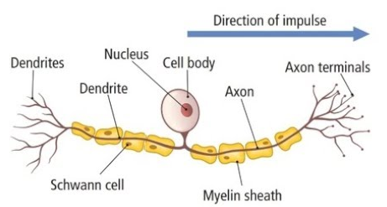
Drawing of a sensory neuron
9. Table showing structural differences between sensory and motor neurons
Sensory neuron | Motor neuron
Long dendrites | Short dendrites
Cell body in the centre of the neuron | Cell body near the start of the neuron
Axon similar length to dendrite | Axon longer than dendrite

QUESTION 4
1. a) Stores neurotransmitter and releases them stimulated by an impulse
b) Provides energy for the release of the neurotransmitter
2. Neurotransmitter move via diffusion, therefore the space needs to be very small for effective diffusion.
3. Every organ and gland is controlled by two sets of nerves that act antagonistically to control involuntary events/ brings about homeostasis. The sympathetic nerves stimulates a response/brings about action and stimulates parts of the body such as increasing the breathing rate where as the parasympathetic nerves inhibits a response/slows down parts of the body such as slow down in breathing rate.

QUESTION 5
1. a) H - medulla oblongata
b) G - central canal
c) C - pituitary gland
d) F - cerebellum
e) B - hypothalamus
2. Cranium 3 meninges cerebrospinal fluid
3. The right hemisphere controls the left side of the body; therefore damage to the right side of the brain will affect the left side of the body.
4. a) spinal cord
b) The ability to form an image is controlled by the cerebrum via the cranial nerves which originates directly from the brain.
c) heart-beat will not be controlled - blood flow to the cells will be affected. No control of breathing-cells will be deprived of oxygen

QUESTION 6
1. Reflex action is a rapid involuntary response to a stimulus received by a receptor whereas a reflex arc is the path taken by an impulse in response to a stimulus.
2. Top left to right: synapse - dorsal root - dorsal root ganglion - dendrite of sensory neuron
Bottom left to right: interneuron – ventral root – axon of motor neuron – motor end plate
4. Receptor nerve endings in the skin of the finger receive the heat stimulus-stimulus is converted into a nerve impulse. The impulse is then conducted via the sensory neuron to the spinal cord via the dorsal root of the spinal nerve. Within the spinal cord the sensory neuron makes a synaptic contact with an interneuron. The interneuron makes a synaptic contact with a motor neuron. The impulse is relayed via the motor neuron along the ventral root of the spinal cord to the muscles of the arm which causes the rapid movement of the away from the heat source
5. The person will become aware of the stimulus but the motor neuron will not be able to transmit the impulse from the interneuron to the effector muscle and movement will not take place/ reaction will not occur
6. No impulses will pass from the receptor to the spinal cord and no reflex action will occur therefore the finger will not move.
7. The myelin sheath breaks down and this slows the transmission of the impulses resulting in a longer time taken for reflexes to occur.

THE EYE
QUESTION 1
1. a) E - iris
b) F - pupil
c) M - blind spot
d) O - lens
e) A - choroid
2. cones
3. cornea-aqueous humour – pupil – lens- vitreous humour-retina
4. The person cannot see/would be blind because the impulses from the retina cannot be transmitted to the cerebrum.

QUESTION 2
1. Reduction in the light intensity
2. The circular muscles of the iris relax and the radial muscles of the iris contracts. The pupil size increases allowing more light to enter the eye
3. Cerebrum

QUESTION 3
1. Accommodation for near vision- ciliary muscles will contract which pulls the ciliary process and the choroid towards the lens. Tension in the suspensory ligaments is released. The elastic lens becomes more convex (fatter) increasing the refractive power of the lens. A clear image is formed on the retina.
2. a) Accommodation will not occur. The refractive power of the lens is low and light rays are not refracted or focused onto the retina. The person can only focus on distant objects.
b) convex lens

THE EAR
QUESTION 1
1. A-pinna B-tympanic membrane C-semi-circular canals
D-auditory nerve E-cochlea F-round window
G-Eustachian tube H-stapes I-incus
J-malleus K-auditory canal
2. a) Traps and directs sound towards the auditory canal
b) Equalizes pressure on either side of the ear drum, allowing the ear drum to vibrate freely
c) Maintains balance
3. The endolymph in the semi-circular canals move. The cristae found in the ampulla are stimulated and converts the stimulus into an impulse which is transmitted via the auditory nerve to the cerebellum from which impulses are transmitted via motor neurons to the effector muscles to balance of the body.
4. The ossicles will not be able to vibrate thus no vibrations will be passed to the inner ear/cochlea will not be stimulated.
5. Sound waves are trapped by the pinna and directed towards the tympanic membrane which causes it to vibrate. These vibrates are passed onto to the ossicles which in turn are passed onto the oval window. The vibration of the oval window sets up pressure waves in the inner ear. Hair cells in the organ of Corti are then stimulated and nerve impulses are sent via the auditory nerve to the cerebrum where the sensation of hearing arises.

QUESTION 2
1. a) Grommets are inserted in the tympanic membrane/ antibiotics are given
b) Mucus in the middle-ear will lead to the blockage of the Eustachian tube which will not be able to equalize the pressure in the middle ear. This results in pressure on the tympanic membrane that may cause the tympanic membrane to burst resulting in hearing loss
2. a) The hearing aid increases the vibrations of the tympanic membrane; however, the cochlea is unable to convert this into a nerve impulse hence the person is still unable to hear.
b) It sends the impulses electronically to the cerebrum allowing the person to hear.

QUESTION 3
1. Females have a faster reaction time than males.
2. Bar graph showing the distance at which the ruler moved for both genders.
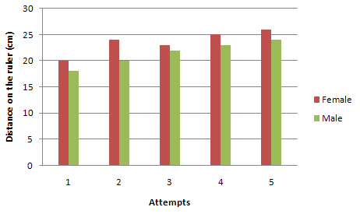

3. Females
4. Participants must be of the same age. Ruler must be the same size. The ruler must be made of the same material. Participants must be the same distance from the bell. The bell must produce the same sound for the same duration. The lighting in the room must be the same.
5. Repeat the investigation several times and calculate the average
Increase the sample size
6. Many attempts give the participants practice and therefore their reaction time improves.

